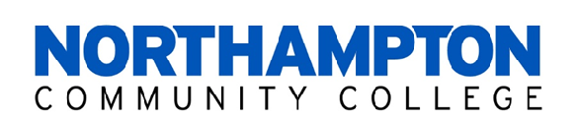

Dear Crafter:

We’d like to invite you to participate in Northampton Community College’s Alumni Association Spring Craft Fair on Saturday, March 15, 2025 in the Arthur L. Scott Spartan Center gym and lobby from 9:00 a.m. – 2:00 p.m. Here is some information about this year’s event:

- Two rental options – see second page.
- There are no guarantees on table location within the gym or lobby. However, a request can be made at the time of registration and placement will be determined on a first-come, first-served basis.
- All crafts must be hand-made by you. Please be specific in your craft(s) description on the registration form.
- Crafters who operate through a storefront business will not be accepted. No commercial vendors will be accepted.
- It has been brought to our attention that some craft items are labeled as “organic.” While we are not expert in the U.S. Department of Agriculture’s (USDA) National Organic Program or FDA regulations, please review the information in the websites listed below to insure you are compliant:
https://www.fda.gov/cosmetics/cosmetic-products/frequently-asked-questions-soap
https://www.ams.usda.gov/services/organic-certification/need-be-certified
- The registration form will be available for download starting Friday, January 3 at https://www.northampton.edu/craftfair. You must mail in your registration form with your check. No registration forms will be accepted by email.
Upon receipt of your paid registration, you will receive a confirmation email, or phone call if you do not have an email address. Additional details about the craft fair will arrive in a separate mailing one month prior to the show.

Please be aware of our refund policy. Refunds will not be given to “no shows” the day of the event; cancellation requests more than one week prior to the event will receive a refund less a $25 processing fee – cancellations within one week of the show will receive no refund. Spaces cannot be subleased to other crafters. In the event of inclement weather resulting in the closing of the College, a full refund will be made to all registrants.

Thank you for your continued support. We look forward to having you on campus for this event! If you have any questions, please contact us at 610-861-5088 or nhutt@northampton.edu.

Sincerely,
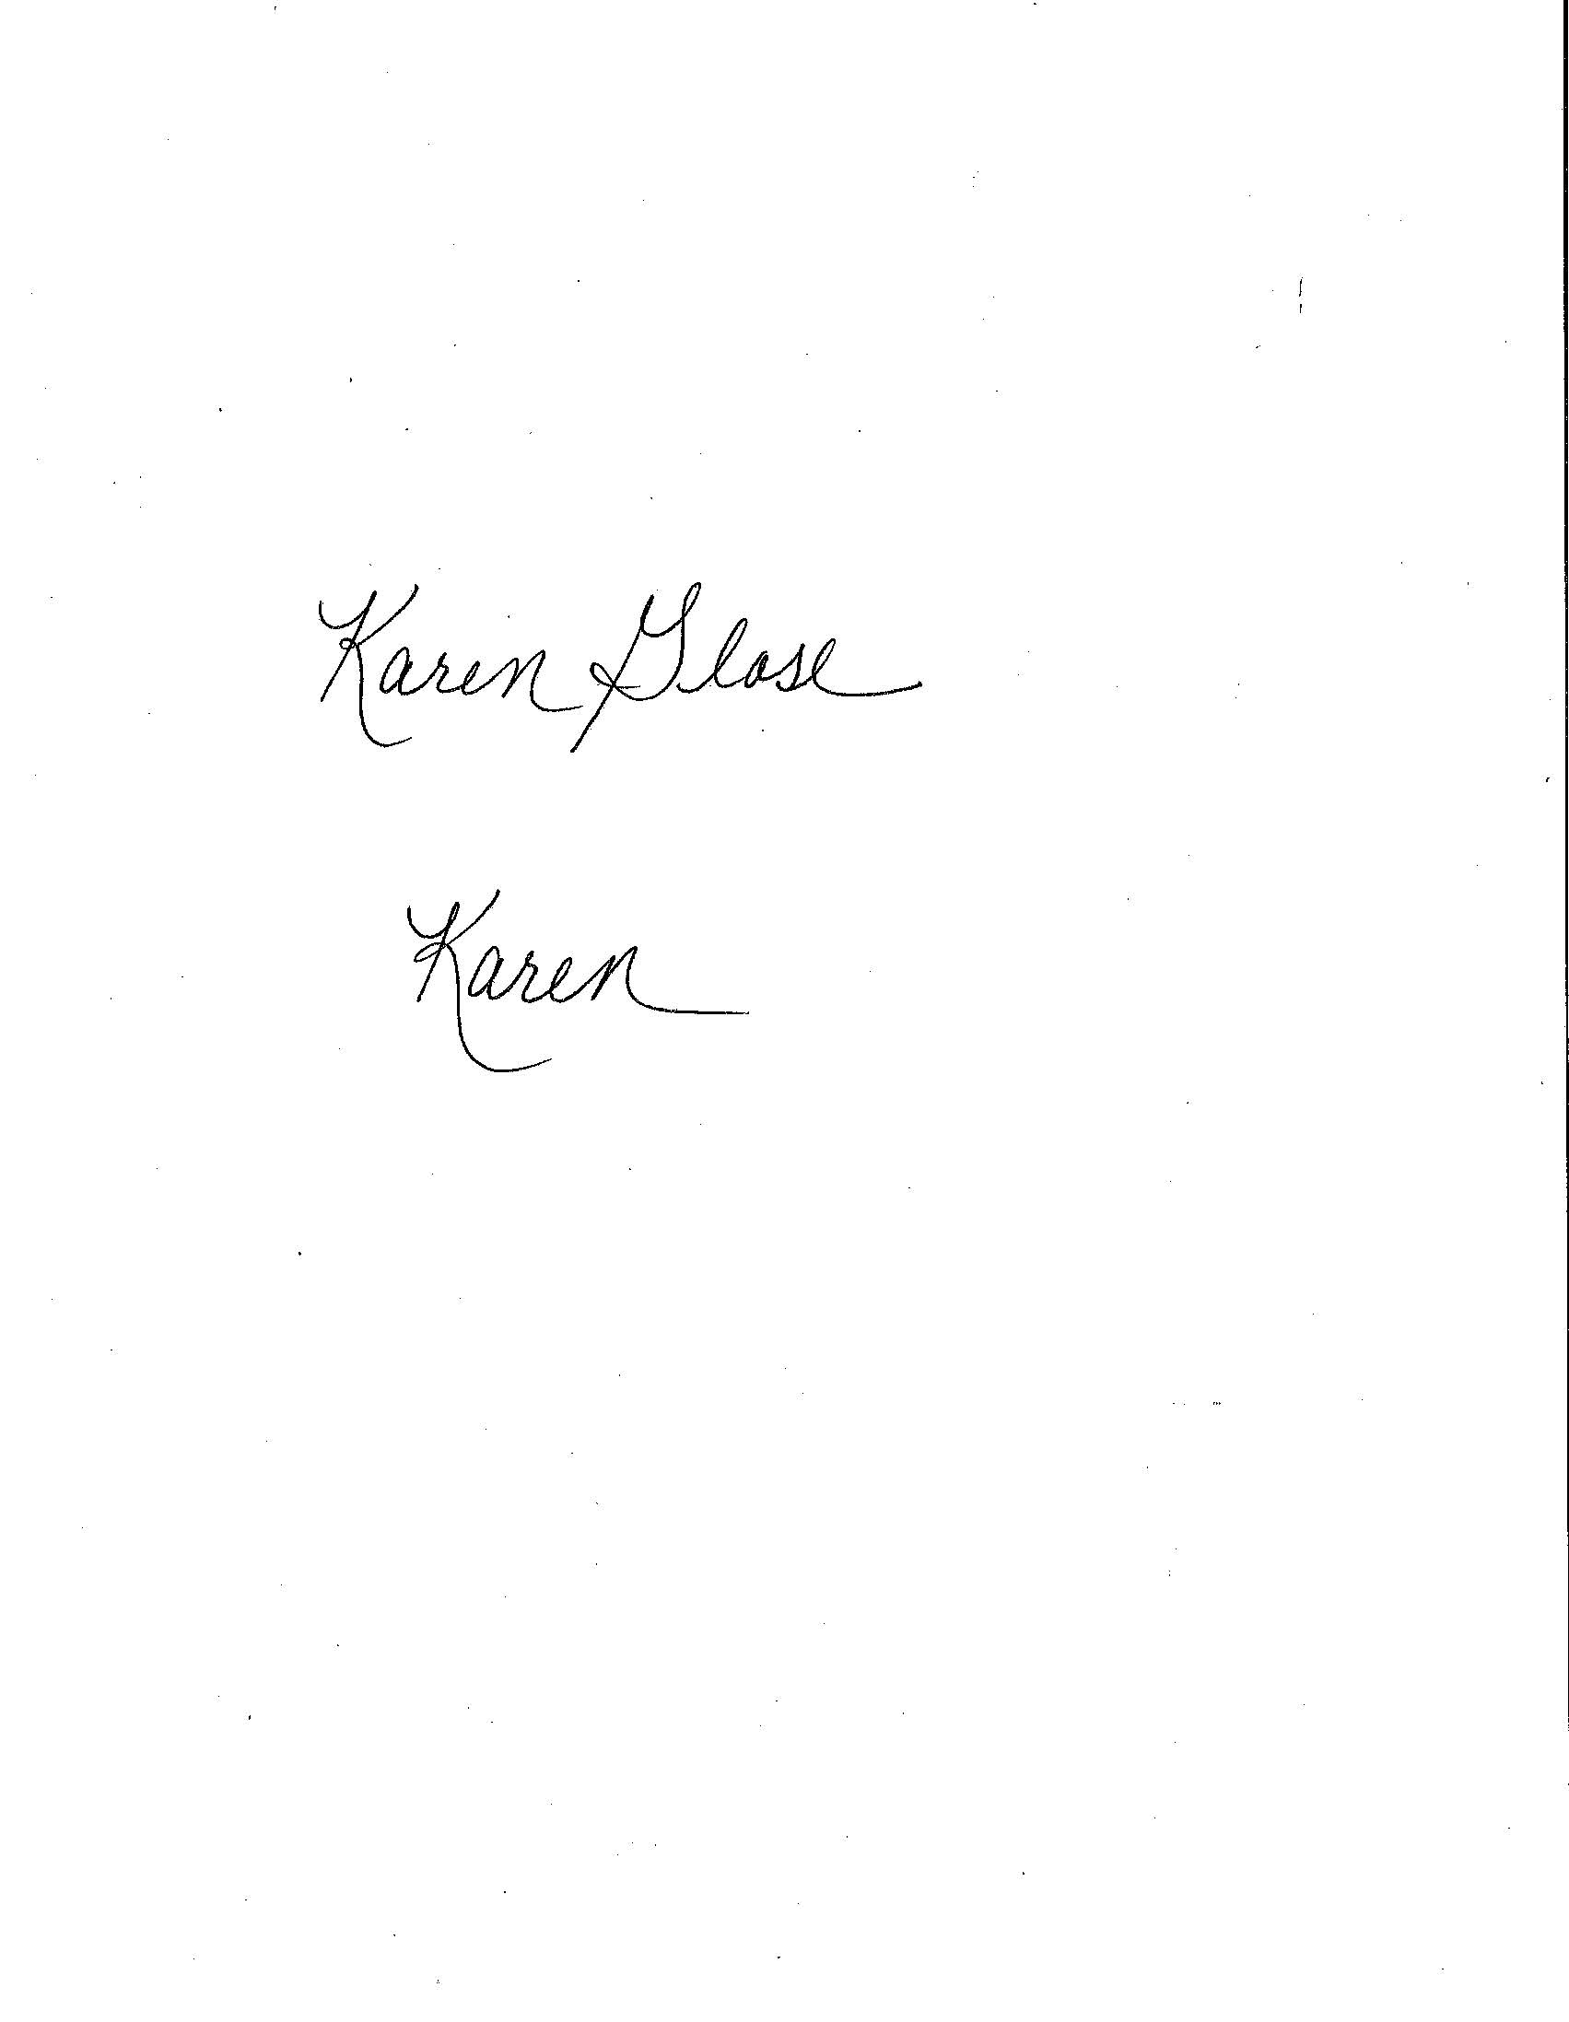
Karen Glose
Director, Alumni Engagement

Northampton Community College
Alumni Association’s
SPRING CRAFT FAIR

Registration Information

Rental options:

Table Rental: $50 registration fee

- One 3’x6’ table and two chairs - ($50 per table/maximum 2 tables per applicant – no exceptions).
- Display items are limited to table space only (as a courtesy to your neighbor).
- Electrical hook up is available for displays. There is an additional $25.00 fee for electric. This must be requested on the registration form.
- No combination table/space rentals.
- No outside tables/chairs are permitted with the table rental.
- No risers of any kind under the legs of the table that would extend the height of the table.

Space Rental: $100 registration fee

- One 10’ x 10’ taped off space with two chairs. Maximum of 2 – 10’ x 10’ spaces.
- Bring your own table(s)/display to fill your space. This option does not include a table. Do not place risers of any kind under the legs of the tables that are used in this setup.
- Display items are limited to the inside of your 10’ x 10’ marked space.
- Electrical hook up is available for displays. There is an additional $25.00 fee for electric. This must be requested on the registration form.

Set up is available Friday, March 14th from 4 p.m. – 6 p.m. and begins Saturday morning at 7 a.m. Craft artisan must be set up by 9 a.m. on Saturday, March 15th.

NCC will advertise the Craft Fair in the following ways:

- Local newspapers
- Campus signage and posters throughout the community
- Online via NCC website, LinkedIn, Facebook
- E-blasts to Alumni, Faculty and Staff

Questions? Contact us at 610-861-5088 or nhutt@northampton.edu

